How Energy Security Affects Data Center Viability: A Five-Country Model
Henry Dalby - IMD MBA 2026
13 August, 2026

I. Compute Is Infrastructure, Not a Commodity
AI infrastructure is being reclassified from commercial commodity to strategic national asset. The AI market is projected to grow from $189 billion to $4.8 trillion by 2033 [1], with annual capital expenditure reaching $765 billion in 2026 and an estimated $1.6 trillion by 2031 [2][3][4]. As this investment concentrates into physical data centers, the countries that host compute gain disproportionate leverage: the ability to “tax it, control who has access to it, and regulate what they do with it”. [5]
Cloud compute is widely traded cross-border, but physical chip access is export-controlled, and latency sensitive, sovereignty-constrained and regulated workloads create demand for regional capacity. [6]
Three constraints make this clear. First, physics; AI inference is projected to overtake training as the primary driver of data center demand by 2027, [7] requiring sub-50 millisecond response times for consumer-facing applications. Network latency between centralized cloud facilities and end-users averages 50–150 milliseconds across transcontinental links, representing 20–40% of total inference latency. [8] Latency-sensitive workloads in healthcare, finance, and autonomous systems demand proximity that no trade agreement can substitute. Second, regulation; 155 countries have enacted 331 data localization regulations as of 2024 (up from 35 countries in 2017) mandating that sensitive data be stored and processed domestically. [9] Third, export controls; U.S. semiconductor restrictions limit NVIDIA GPU access to Saudi Arabia under security conditions [10], subject India’s advanced-chip imports to export licensing [6], and impose tariffs adding $48–78 million to a 100 MW U.S. build. [11]
Proximity to compute presents a dominant geopolitical advantage. Local data centers deliver regulatory compliance, latency reduction, and insulation from supply-chain disruption. But they carry significant costs. Energy availability, not price, is the binding constraint, and countries with high cost of capital or constrained grids risk building infrastructure that cannot recoup investment before the technology cycle resets.
The convergence of latency physics, data sovereignty law, and export-control risk makes dependence on foreign infrastructure untenable. The real question is whether countries can energize fast enough to capture value before the window closes.
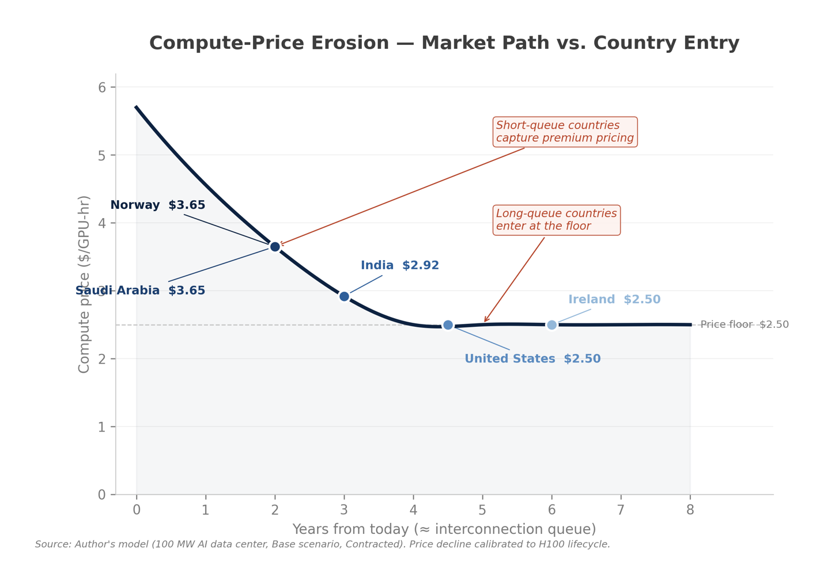
Fig. 1: Market path versus each country’s entry point after exiting the energy queue. Countries that energize later enter a collapsed market with a lower compute price.
Siting countries stand to capture direct economic value from construction spending and energy demand. The long-term value of compute will be unlocked downstream from human capital, attracted by AI-driven innovation in pharmaceuticals, software development, and machine learning [5].
The race to energize data centers makes AI strategy dependent on grid capacity and interconnection queue. While some hyperscalers have turned to off-grid energy alternatives [12], countries that wish to compete must energize data centers quickly or risk becoming uncompetitive in the race to AI sovereignty.
To isolate the core drivers of this tension I asked a simple question:
How does national energy security affect the viability of a data center project?
Using a unit-economics financial model of a 100 MW data center, I ranked five countries by NPV. Each represents an energy-security archetype:
- Norway—concentrated hydro-power [13]
- Ireland—moratorium-constrained supply [14]
- Saudi Arabia—abundant hydrocarbon economy [15]
- United States—resilient energy grid strategy [16]
- India—cheap power but high cost of capital [17][18]
The model identified two significant levers to project viability: offtake contracts and time to power. Offtake contracts are critical for increasing revenue, raising NPV $0.67–$2.16 billion per site. But for grid-connected projects, time to power determines the winners.

II. Surging Demand Is Outpacing Supply
Data center colocation vacancy is at a record low: global average vacancy is 6.7% (down from 8.3%) and 74% of capacity under construction is pre-leased [19]. Neocloud markets are expected to increase 7x by 2030, from $25 billion to $180 billion [20]. Demand for compute is driving B200 chip prices up — rising 24% in Q1 2026 and 16% YoY [21][22].
Market demand is driving supply faster than builders can produce compute infrastructure.
Despite willing investment, energy availability is slowing the activation of AI infrastructure — the markets that cannot energize fast enough will fall farther behind the longer they wait [4].

III. Time to Power Is the Binding Lever in Value Creation
The model identifies three levers that drive NPV ranking:
- Offtake contracts significantly increase NPV by improving occupancy, reducing cost of capital, and reallocating risk to the demand side.
- Holding cost — each year waiting for power costs ~$26 million.
- Compute price erosion — projects with longer hold-periods enter a collapsed market with a lower GPU compute price. The longer the idle-shell holding period, the more the undeployed capital and eroding compute price cost.
Since compute price erodes as competitor supply comes online, the length of a country’s grid-interconnection queue — not the price of its power — sets the entry price a data center earns. That order defines which countries can profitably host AI.
Offtake contracts amplify the winners but cannot rescue slow-queue losers. Ranking is driven by time-to-power and cost structure, but the price lever is inert for floored slow-queue sites.
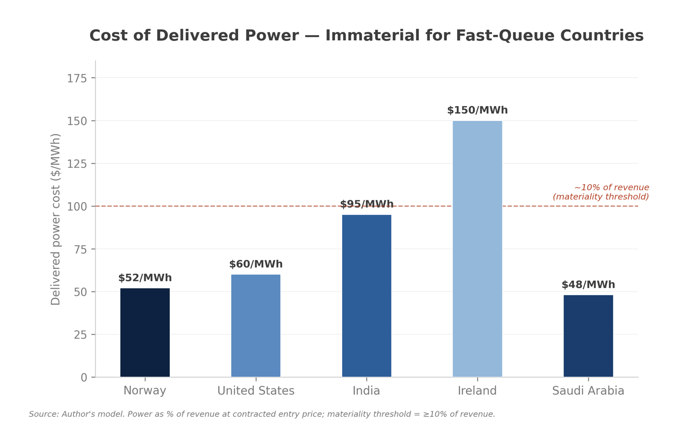Fig. 2: Power is immaterial (~2–3%) for the base scenario winners and only becomes material (10%+) where a long queue erodes compute price to the floor.
India is capital-efficient but capital-expensive: high IRR with low NPV indicates a higher risk premium.
The country ranking depends on the metric: if ranking countries by IRR, India overtakes the US due to higher capital efficiency. This fails to represent India’s higher risk premium but demonstrates a necessary insight; India’s problem is cost of capital, not operations. Rising 10-year treasury yield in the United States signals increasing cost of capital (0.67% in May 2020 and 4.47% in August 2026) [23]; this will further impede capital-intensive data center builds if the trend continues and could invert the US-India viability ranking.
Payback and break-even utilization represent project resilience but not value. By both metrics, Ireland sits at the bottom in base and bull scenarios: there is no occupancy level at which it clears cost of capital.
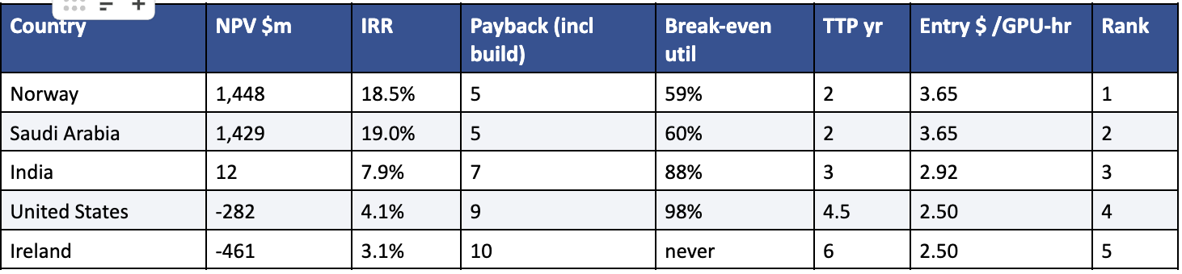
Fig. 3: table of country rankings in base scenario, contracted.
The base-scenario ranking holds across both deal types. In the bull-scenario, Saudi Arabia overtakes Norway but both are highly profitable; Ireland remains last but turns positive. In the bear-scenario, the ranking inverts: all countries are negative and Ireland becomes the least-bad due to its low tax rate and WACC. The full six-state output is available in the appendix.
NPV ranks are conditional on lawful chip access: a co-equal constraint to time to power.
Trade limitations are not represented as a cost line — and this affects all five countries. Ireland’s new CRU self-generation rule is a real siting limitation [14]. In the United States, tariffs on imported AI-server components add roughly $48–78 million to a 100 MW build [11]. Saudi Arabia’s access to Blackwell chips is conditional under US security and reporting requirements [10], and India’s chip access is conditional on US licensing, which is currently active but not unconditional. [6] The model also does not value water availability, which is a live constraint in Saudi Arabia and a rising risk in India [24][25].
Time-to-power is the critical siting criterion for hyperscalers [26]. Low energy availability is driving a large share of 2026 capacity to 2028 or later [27]; sites with shorter interconnection queues offer both shorter payback and higher returns.
GPU life is the binding constraint across the data center system, with an operable lifespan of five years [28]. Countries that deploy faster capitalize on economic value. Fixed costs grow significantly with long time-to-power. At today’s prices, the cost of power is immaterial. For countries with a long energy queue that erodes compute price to the floor, cost of power becomes material.
The binding energy limitation is time, not cost: each year in the interconnection queue accrues ~$26 million in holding cost and risks compute price erosion.
Countries with the strongest energy security have the shortest payback period (Norway and Saudi Arabia at a five-year horizon). The weakest performer has the longest break-even time (Ireland with a ten-year horizon). Cost buildup from the holding period combined with eroded compute price penalizes projects with long time to power.
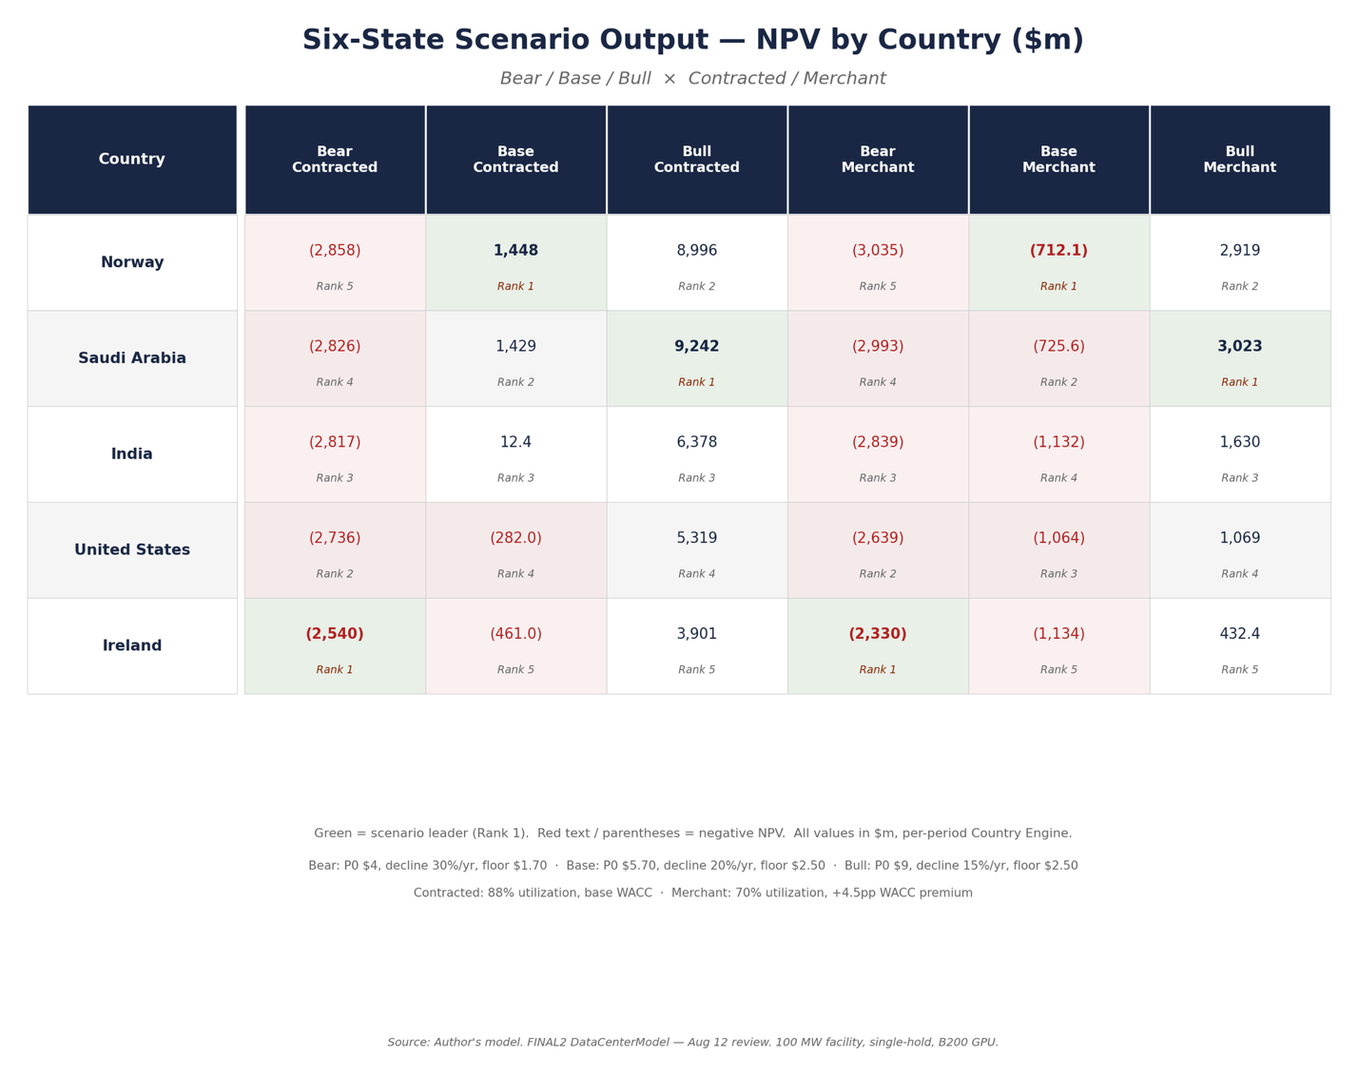
Fig. 4: Holding costs erode NPV across all countries and extends payback period. Ireland accrues the most significant disparity between actual NPV and instant power for a total difference of ~$5.5BN: $160MN is direct carrying cost and the remainder is deferred cash flows, compute-price erosion during the wait, and discounting.

IV. Offtake Contracts Scale Value But Cannot Save Slow Sites
Pre-sold capacity is the single biggest determinant of economic viability. Offtake contracts increase revenue by combining three variables:
- Risk transfer—contracted buyers assume market price and volume risk — stabilizing cash flows and encouraging lenders to invest. With a contract, the price-lock insulates the supplier against rental erosion — a proven downside in merchant infrastructure projects [29].
- Creditworthiness—the tenant’s creditworthiness presupposes long-term capital pricing; construction debt is often refinanced at significantly lower rates with longer terms [30].
- Discount-rate reduction—The model applies a +4.5pp premium to the projected hurdle rate for merchant builds, reflecting the higher risk of unsecured cashflows [31][32]. This is the single largest driver of contracted-merchant spread.
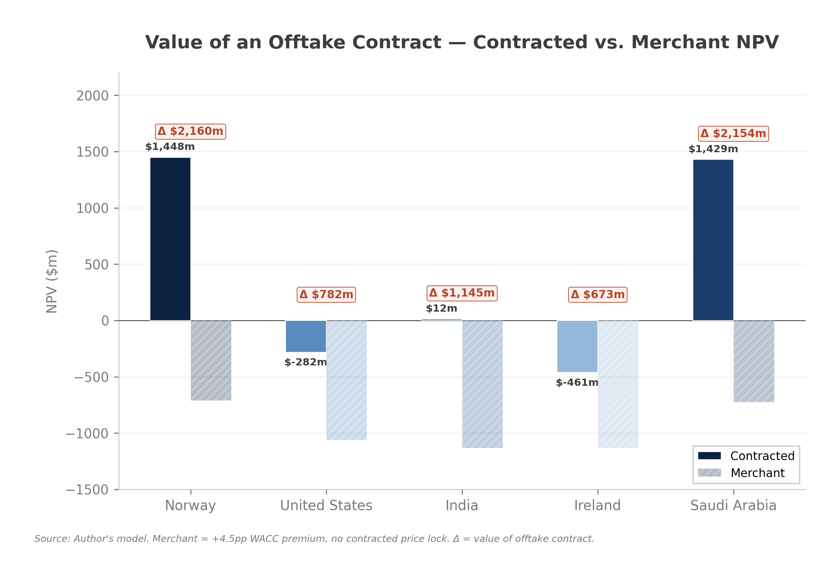Fig. 5: Speculative builds return negative NPV in the single-hold model. Offtake contracts make the single-hold data center viable in winning countries but cannot save projects with long holding periods.
Offtake contracts lift occupancy, ranging in value from $0.67 billion (Ireland) to $2.16 billion (Norway).
A debt-financed GPU cluster breaks even at ~70% utilization [33]. The model credits contracted builds with an 18-point occupancy premium over speculative builds. As compute scarcity has eased, recent analysis puts break-even utilization at 85–90% [34] — modeled merchant assumptions are moving from break-even to loss-making.
Existing stock sits at 1.4% vacancy and 74% of construction capacity is pre-leased; the model uses paid occupancy to unify real-estate occupancy with GPU utilization as a fraction of the fleet earning paid revenue [16][19].

V. Three Lenses of Success Indicate Three Different Winners
Hyperscalers in the US are pursuing on-site generation to reduce grid-connection costs and guarantee reliable supply. In 2025, Meta bought rights to solar farms in Missouri and Arizona; Amazon bought contract rights to a nuclear plant adjacent to its data center campus in Pennsylvania [35].
The model scores energy security using a custom proxy based on the World Energy Council’s Trilemma framework [36]. Three indicators are equal-weighted (0-100); import independence (IEA self-sufficiency) [37], generation diversity (Ember 2024 electricity mix) [38], and firm generation share (all output except variable wind and solar) [38]. The resulting rank is consistent with the WEC’s published energy-security grades [36].
Economics, energy security, and carbon emissions indicate three different winners.

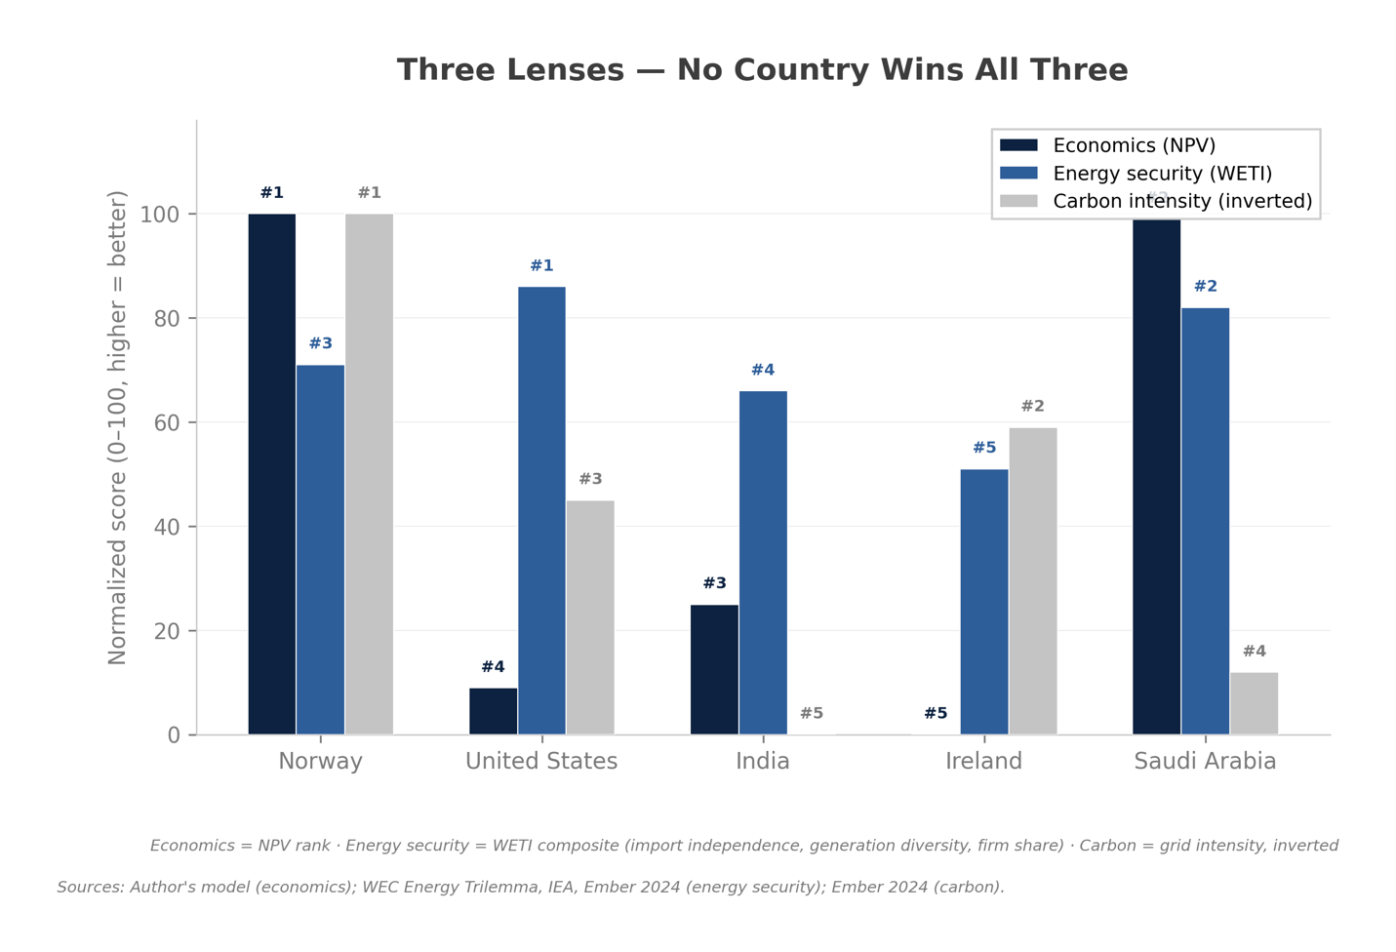Fig. 6: (1=worst, 5=best) Norway wins economics, the United States wins energy security, and Norway wins carbon.
No country wins all three categories. Saudi Arabia is strong on both economics and security but ranks dirtiest of the economically viable sites: providing 100% of domestic power as a world-leading oil producer, at the expense of carbon emissions [15]. Norway wins economics and carbon but carries a real energy security caveat: 88% of grid energy is concentrated in hydro-electric infrastructure, exposing risk from concentration and drought [39]. The United States is the most energy-secure grid but offers economically weak value due to long interconnection queues.
AI sovereignty is achievable by countries who control the infrastructure, energy, and external costs of compute.
Carbon price provides an additional lens. The carbon-adjusted NPV does not feed the P&L due to inconsistent policy across geographies: the US EPA 2023 social cost of carbon prescribes $190/t while the EU ETS clocks in at $80–90/t [40].
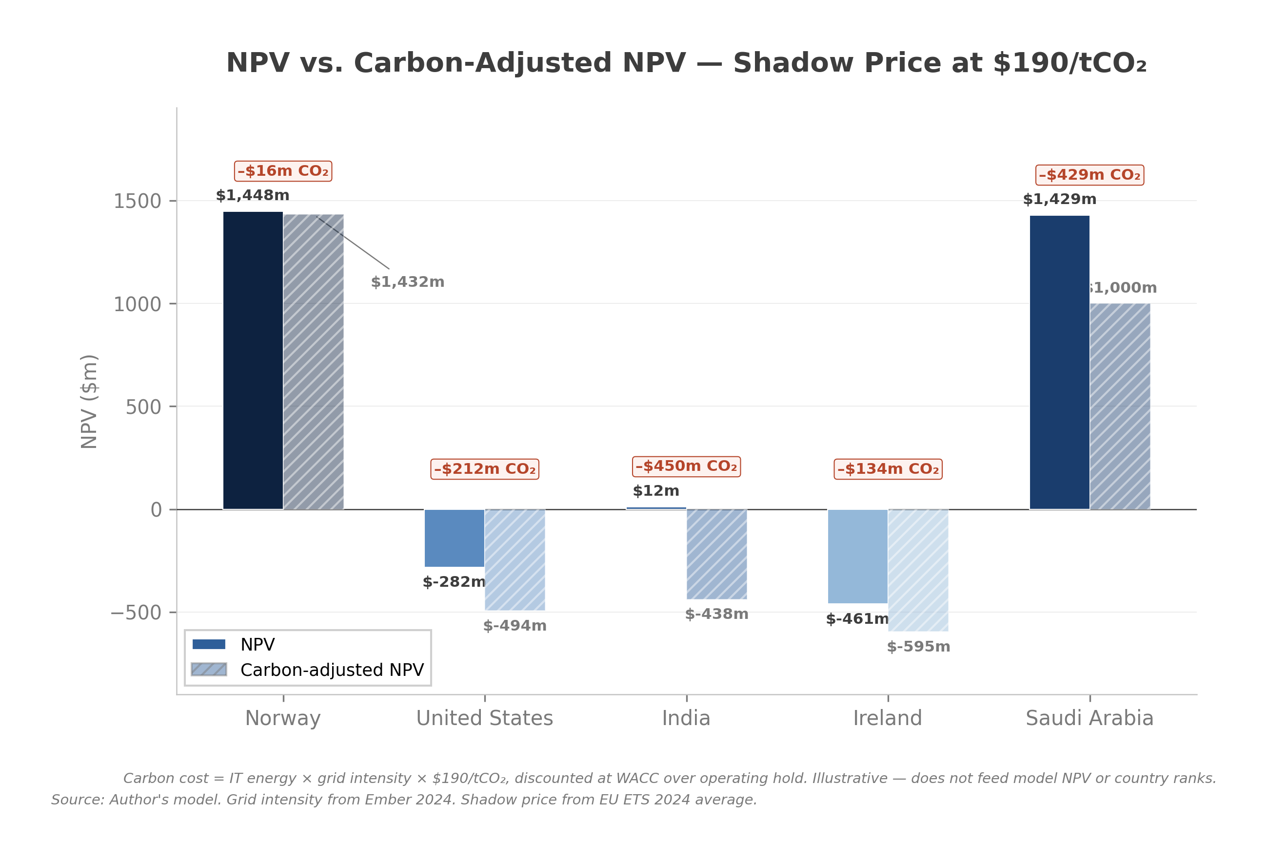Fig. 7: Incorporating a pure carbon tax would favor Norway’s 98% renewable grid while disadvantaging Saudi Arabia [39].
A pure $/MWh ranking favors cheap but dirty energy grids, whereas a unilateral carbon price would favor renewables. The model derives a carbon-adjusted NPV as follows: grid CO₂ = IT energy × grid CO₂ intensity, costed at the US $190/t and discounted over the operating hold using the same annuity as revenue.
80% of global data center capacity is at elevated risk from environmental hazards [41]; over half of top hubs are in markets exposed to chronic heat and drought that degrade efficiency and raise costs [42]. Data centers consume ~1.5% of global electricity with demand growing 17% in 2025. [43]
Countries like Saudi Arabia are most exposed to rising temperatures and water scarcity [44]. PUE climbs materially with ambient heat; dry cooling suppresses water use but raises electricity draw — surfacing the cost as power even when water is minimized. [45][46]

VI. Inference Is Shifting Siting Logic Toward Demand Centers
The model ranks on unit economics and rewards energy-secure locations. That advantage is strongest for AI model training, which is latency-insensitive and can be sited wherever power is abundant. Inference, projected to overtake training as the primary driver of AI data-center demand by 2027 [7], is latency-bound and must sit near demand centers. [47] Norway and Saudi Arabia’s advantage is clearest for training campuses and narrower for latency-sensitive inference.
Latency-sensitive inference capacity will increasingly be sited near population and demand centers as AI demand shifts from training to inference [7].
Price and time-to-power vary within each country depending on generation strategy and firming cost. Hyperscalers are increasingly investing in off-grid power [12]. A behind-the-meter power grid is emerging in the US, driven by rising demand for compute [12]. Carnegie Endowment models that US data centers are reducing time to power to a two-year queue using off-grid energy [5].
Hyperscalers are using mobile gas turbines for fastest time to power, deferring solar-plus-storage and heavy-duty gas turbines for strategic long-term projects (12–36 months) [12]. The race to energize data centers is driving unprecedented growth in power grid infrastructure and investment in long-term renewable power hubs [35][48]. Projects like Data City in Dallas promise low-cost renewable energy firmed 24/7 as behind-the-meter supply to attract hyperscalers [5][26].
Solar is the cheapest bare energy cost when generating, but firming for the permanent load of a 100 MW data center is technically demanding and capital-intensive. Cheap power is not synonymous with available power.

VII. Siting Is a Sovereignty Decision, Not a Cost Decision
Data center operators, investors, and policymakers can harness compute demand to advance national energy infrastructure. Compute price reflects the premium the market places on data centers. First movers profit most — as do first mover countries where AI-generated value compounds over time. As the market competes compute price down to the floor, long-hold projects will not only suffer value erosion but risk missing the window to establish AI sovereignty altogether [20].
For operators, siting is an energy security and time to power decision, not a cost decision. A secure, available grid is a precondition for financial health.
For investors, the risks are idle-shell holding time and price erosion that can doom a project before it energizes. Offtake contracts unlock significant value but amplify strong sites rather than rescue slow-queue ones.
For policymakers pursuing competitiveness, resilience, and sovereignty, energy policy is AI-industrial policy, given how decisively time to power governs where projects can be built.
Secure, available grids offer the greatest value for data centers—providing leverage, value, and sovereignty to the countries that build fastest.

VIII. Methodology
The model validates findings from Carnegie Endowment’s June 2026 The Compute Coalition, revealing that time-to-power is the most important driver of economic returns [5]. However, this model differentiates across four key criteria:
- A unique five-country set selected as energy-security archetypes.
- A computed project break-even rental threshold (~$2.50) for a B200 chip, illustrating revenue fluctuations across a single-hold GPU lifecycle.
- The grid-interconnection derivation directly contradicts Carnegie’s behind-the-meter energy model. This is exemplified in the United States where queue time derives to 4.5 years compared to just two years for Carnegie’s choice to model a fast-path to power [5].
- A three-lens evaluation assessing economics (NPV) alongside energy security and carbon emissions.
Inputs and assumptions
Assumptions are standardized across all five countries and structured with reference to PwC financial modelling guidelines (one-directional flow, no hard-codes in formulas, sourced inputs, and live reconciliation checks) [49]. Inputs are sourced and referenced. Levers are defined in the model map and isolated in the model. Sensitivity analysis identifies the highest-materiality levers.
The model assumes unconditional access to Blackwell B200 GPUs and simplified corporate tax rules (statutory rate, unlevered, no loss carryforward).
Three toggles adjust market scenario (Bear/Base/Bull), country, and deal type (contracted/merchant). The data center model implies a single-hold basis: build, operate for GPU life, then liquidate at a pre-tax yield. GPU unit is reconciled to a single accelerator (Blackwell B200) [2][50].
The model reconciles by computing every country’s cash flow in two independent per-period engines (an explicit DCF and a comparison tab using closed-form annuity algebra)—checking that they agree. This catches formula errors but does not constitute an independent valuation method.
The model deliberately leans conservative across revenue-side inputs, tax, and unlevered terminal value. Networking fabric, GPU attrition, water, and decommissioning costs are folded into costs or omitted.
Time to power is derived from United States grid dispersion data. The US range derives bear and bull scenarios from a single-point sourced interconnection queue time for the other four countries.
Interconnection queue data for Norway, India, Ireland, and Saudi Arabia are assumptions informed by the best available public data, not observed data-center connection durations. The US input is a proxy (generator queue); non-US inputs are regulator-sourced point estimates without published duration distributions.
The contracted-merchant spread combines three effects: higher paid utilization (88% vs 70%), a locked compute price (vs continued erosion), and a lower discount rate (~6.3–7.8% vs ~10.8–12.3%). The utilization and discount-rate effects are the larger drivers; a full decomposition is available in the workbook.
Single-hold period
A single-hold period is calculated at five years — the GPU operating life [51]. Once GPUs depreciate, the powered shell and interconnection sell at a conservative 45% salvage [52]. GPUs are expected to collapse to 10% salvage by year five once two newer generations have shipped [52]. The single-hold with 10% GPU salvage is deliberately conservative given Rubin-era resale pressure by 2031 [28].
The single-hold cycle is a simplification for model legibility. Realistically, an operator is more likely to re-tenant the powered shell for a second GPU cycle. This could add value (especially for short-queue sites with live interconnections); omitted costs (networking fabric, GPU attrition, water, decommissioning) would reduce it. The net direction is not determined by this model.
Operations begin at the start of the year to simplify fractional-year ramp-up complexity. GPUs are bought and installed the year when power arrives — an industry convention that conserves absolute NPV and hedges against premature GPU depreciation [28].
Sensitivity analysis
While absolute NPV is assumption-contingent, the model shows NPV is most sensitive to three levers: compute price (for countries above the floor), GPU density, and GPU chip price. These are supported by Carnegie Endowment’s finding that IT represents ~80% of capex: GPUs are the most valuable asset of a data center [5].
In contrast, supplied power is low materiality. Power is <5% of revenue for fast-queue winners, rising to ~12% where the queue erodes price to the floor [5].
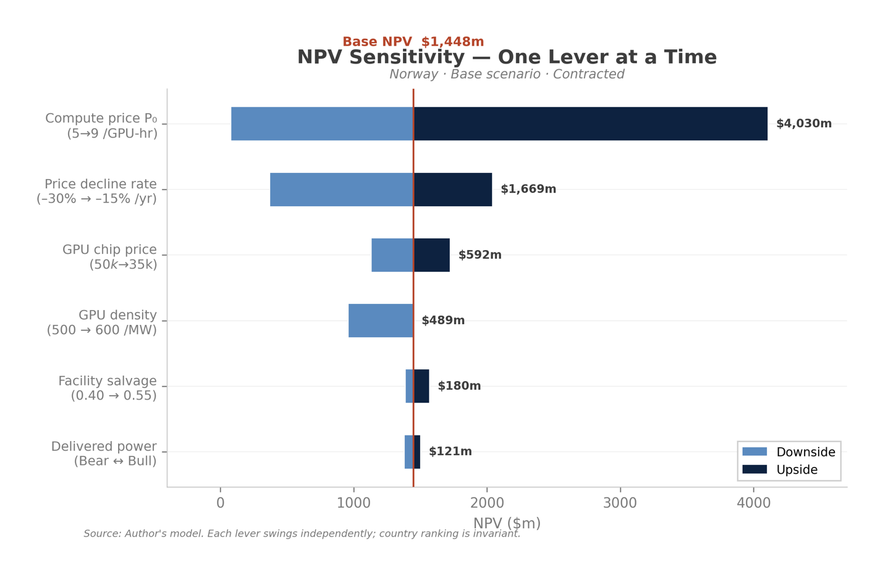
Fig. 8: Compute price ranks as the highest sensitivity with the highest volatility. Delivered power remains immaterial.
GPU price erosion
Compute price erodes toward the full-cost floor. The floor is derived as the break-even rental rate at which each country reaches NPV=0, derived from its own cost stack (capex, power, O&M, WACC, tax). The lowest-cost producer sets the project break-even rental threshold (Norway at $2.50). The floor is cross-checked against the Silicon Data B200 index.
The model builds compute price floor based on the H100 cycle: 18-month appreciation followed by 18-month decline of 50% [29]. The floor is set to 20% of peak price before rebounding to 30%. The model compresses this into a base-case 20% annual price erosion. The price floor presumes B200 follows the same cycle as H100 [21].
The calculated price floor does not feed assumptions because it is derived from the engine’s own break-even output. Instead, the floor lives as an input ($2.50) in the engine; the derivation mechanism derives break-even independently and reconciles it to the input with two live checks and a $0.10 tolerance. This pattern is used for the WACC and power build-up tabs.
Break-even is provably revenue-invariant: calculated as full cost divided by GPU hours. Sensitivity analysis shows revenue can swing dramatically while the compute floor price holds.

NPV ranking versus absolute value
The NPV ranking discussed in this article is the base-scenario (contracted). Three patterns emerge across the six states. In base, Norway and Saudi Arabia lead and Ireland cannot clear cost of capital. In bull, Saudi Arabia overtakes Norway and all five countries are profitable. In bear, the ranking inverts toward least-bad survivors: Ireland is least-negative due to its 12.5% tax rate and lowest WACC. Absolute NPV swings 5-8x across scenarios; the top-two/bottom-two grouping is the most stable output, but the ranking is not scenario-invariant.

Fig. 9: Output data from all 6 scenarios: Bear/Base/Bull X Contract/Merchant
The model proves country ranking by NPV and shows clear directional sensitivities given cited inputs. NPV rankings are scenario-conditional; absolute NPV is defensible but not a strict calculation. Rankings remain resilient across a 5–8x swing in absolute value.
The AI system is evolving under changing policy mandates, supply-chain chokepoints, and geopolitical competition. This model is a snapshot of unit economics that defensibly indicates time-to-power and contracting as critical gates in data center value. Adjacent chokepoints — chip supply, water access, and energy infrastructure — are areas for further model-driven research.

IX. References
Full model access is available HERE.
[1] United Nations Conference on Trade and Development. (2025). AI market projected to hit $4.8 trillion by 2033, emerging as dominant frontier technology. https://unctad.org/news/ai-market-projected-hit-48-trillion-2033-emerging-dominant-frontier-technology
[2] SemiAnalysis. (2024, July 16). GB200 component and supply-chain model. https://semianalysis.com/2024/07/16/semianalysis-gb200-component-and/
[3] Gartner. (2026, January 15). Gartner says worldwide AI spending will total $2.5 trillion in 2026 [Press release]. https://www.gartner.com/en/newsroom/press-releases/2026-1-15-gartner-says-worldwide-ai-spending-will-total-2-point-5-trillion-dollars-in-2026
[4] Goldman Sachs. (n.d.). Tracking the trillions: The assumptions shaping the scale of the AI build-out. https://www.goldmansachs.com/insights/articles/tracking-trillions-the-assumptions-shaping-scale-of-the-ai-build-out
[5] Carnegie Endowment for International Peace. (2026, June). The compute coalition: How to build the future of AI in the free world. https://carnegieendowment.org/research/2026/06/the-compute-coalition-how-to-build-the-future-of-ai-in-the-free-world
[6] U.S. Bureau of Industry and Security. (2026, January 15). Revision to license review policy for advanced computing commodities. Federal Register. https://www.federalregister.gov/documents/2026/01/15/2026-00789/revision-to-license-review-policy-for-advanced-computing-commodities
[7] JLL. (n.d.). Data center outlook. https://www.jll.com/en-us/insights/market-outlook/data-center-outlook
[8] Barros, S. (2025). Solving AI foundational model latency with Telco infrastructure. arXiv preprint, arXiv:2504.03708. https://arxiv.org/abs/2504.03708
[9] EUI Cadmus. (2024). Data localisation regulations (2000–2024). https://cadmus.eui.eu/entities/publication/a4609bfc-68d7-44cd-ace1-555d4ee37cfb
[10] U.S. Department of Commerce. (2025, November 19). Statement on UAE and Saudi chip exports [Press release]. https://www.commerce.gov/news/press-releases/2025/11/statement-uae-and-saudi-chip-exports
[11] Shedletsky, A.-K. (2026, February 18). AI data centers paid $6B+ in tariffs in 2025 — A cost to U.S. AI competitiveness? Instrumental. https://instrumental.com/resources/build-better-news/ai-data-centers-paid-6b-in-tariffs-in-2025-a-cost-to-u-s-ai-competitiveness/
[12] Rabobank. (n.d.). The sprint: Data centers are building a parallel energy system in the US. https://www.rabobank.com/knowledge/d011524694-the-sprint-data-centers-are-building-a-parallel-energy-system-in-the-us
[13] Low Carbon Power. (n.d.). Norway. https://lowcarbonpower.org/region/Norway
[14] Data Center Dynamics. (2025). EirGrid says no new applications for data centers in Dublin till 2028. https://www.datacenterdynamics.com/en/news/eirgrid-says-no-new-applications-for-data-centers-in-dublin-till-2028/
[15] U.S. Energy Information Administration. (n.d.). Saudi Arabia: Country analysis. https://www.eia.gov/international/analysis/country/SAU
[16] U.S. Energy Information Administration. (2025, August 12). The United States exported 30% of the energy it produced in 2024. Today in Energy. https://www.eia.gov/todayinenergy/detail.php?id=65924
[17] Ministry of New and Renewable Energy. (2025, April 10). India’s renewable energy capacity achieves historic growth in FY 2024–25 [Press release]. Press Information Bureau. https://www.pib.gov.in/PressReleasePage.aspx?PRID=2120729
[18] International Energy Agency. (n.d.). The cost of capital in clean energy transitions. https://www.iea.org/articles/the-cost-of-capital-in-clean-energy-transitions
[19] CBRE. (2026). Global data center trends 2026. https://www.cbre.com/insights/reports/global-data-center-trends-2026
[20] Synergy Research Group. (n.d.). Neocloud market size [Data set, via SemiAnalysis GPU Cloud Index]. https://gpu-index.semianalysis.com/
[21] Silicon Data. (2026). SDB200RT B200 rental-price index and SDH100RT H100 index. https://www.silicondata.com/products/silicon-index
[22] getDeploying. (2026, August 7). NVIDIA B200 cloud GPU pricing. https://getdeploying.com/gpus/nvidia-b200
[23] Macrotrends. (n.d.). 10-year treasury bond rate yield chart. https://www.macrotrends.net/2016/10-year-treasury-bond-rate-yield-chart
[24] WRI India. (2026, May 18). More than half of India’s data centres are in water-stressed regions. https://wri-india.org/data/more-half-indias-data-centres-are-water-stressed-regions
[25] World Resources Institute. (n.d.). Aqueduct 4.0 water risk atlas: Country rankings. https://www.wri.org/data/aqueduct-40-country-rankings
[26] PR Newswire. (n.d.). Energy Abundance announces Data City Texas: The world’s largest behind-the-meter data center hub powered by 100% 24/7 green energy [Press release]. https://www.prnewswire.com/news-releases/energy-abundance-announces-data-city-texas–the-worlds-largest-behind-the-meter-data-center-hub-powered-by-100-247-green-energy-302407052.html
[27] Wood Mackenzie & JLL. (2026). Time to power by generation strategy [Industry analysis].
[28] theCUBE Research. (2025). Resetting GPU depreciation: Why AI factories bend but don’t break useful-life assumptions. https://thecuberesearch.com/298-breaking-analysis-resetting-gpu-depreciation-why-ai-factories-bend-but-dont-break-useful-life-assumptions
[29] SemiAnalysis. (n.d.). The great GPU shortage: Rental capacity. https://newsletter.semianalysis.com/p/the-great-gpu-shortage-rental-capacity
[30] Skadden, Arps, Slate, Meagher & Flom. (2025, September). Hyperscaler data centers. https://www.skadden.com/insights/publications/2025/09/insights-september-2025/corporate/hyperscaler-data-centers
[31] CoreWeave, Inc. (2026). Form 10-K (Fiscal year ended December 31, 2025). U.S. Securities and Exchange Commission. https://www.sec.gov/Archives/edgar/data/1769628/000176962826000104/crwv-20251231.htm
[32] Bloomberg. (2026, June 2). CoreWeave-tied data center raises $900 million in junk-bond sale. Bloomberg. https://www.bloomberg.com/news/articles/2026-06-02/coreweave-tied-data-center-raises-900-million-in-junk-bond-sale
[33] ModulEdge. (n.d.). Neocloud. https://www.moduledge.com/blog/neocloud
[34] ModulEdge. (n.d.). Neocloud. https://www.moduledge.com/blog/neocloud
[35] Epoch AI. (2024). Epoch AI impact report 2024. https://epoch.ai/latest/epoch-impact-report-2024
[36] World Energy Council. (2024). World energy trilemma 2024. https://www.worldenergy.org/transition-toolkit/world-energy-trilemma-framework
[37] International Energy Agency. (2024). World energy balances [Data set]. https://www.iea.org/data-and-statistics/data-product/world-energy-balances
[38] Ember. (2024). Global Electricity Review 2024. https://ember-energy.org/latest-insights/global-electricity-review-2024/
[39] United Nations Regional Information Centre. (n.d.). Renewables rising: Norway among four countries reshaping energy security. https://unric.org/en/renewables-rising-norway-among-four-countries-reshaping-energy-security/
[40] U.S. Environmental Protection Agency. (n.d.). Social cost of greenhouse gases. https://www.epa.gov/environmental-economics/scghg
[41] CNBC. (2026, June 18). Data center climate change study. https://www.cnbc.com/2026/06/18/data-center-climate-change-study.html
[42] Maplecroft. (n.d.). Majority of world’s top data centre hubs face array of rising heat-related risks. https://www.maplecroft.com/solutions/supply-chain-risk/insights/majority-of-worlds-top-data-centre-hubs-face-array-of-rising-heat-related-risks/
[43] International Energy Agency. (n.d.). Energy and AI. https://www.iea.org/reports/energy-and-ai
[44] World Resources Institute. (n.d.). Aqueduct projected water stress country rankings. https://www.wri.org/data/aqueduct-projected-water-stress-country-rankings
[45] Packet Power. (n.d.). Warmer weather impacts data center cooling and power consumption. https://www.packetpower.com/warmer-weather-impacts-data-center-cooling-and-power-consumption
[46] Clear Comfort. (n.d.). Water-energy trade-off: Cooling choices for data center use. https://clearcomfort.com/water-energy-trade-off-cooling-choices-data-center-use/
[47] CBRE Investment Management. (n.d.). Data centers: Ain’t no mountain high enough. https://www.im.com/insights/articles/data-centers-aint-no-mountain-high-enough
[48] U.S. Energy Information Administration. (2026, February 20). New U.S. electric generating capacity expected to reach a record high in 2026. Today in Energy. https://www.eia.gov/todayinenergy/detail.php?id=67205
[49] PwC Australia. (n.d.). Global financial modelling guidelines. https://www.pwc.com.au/deals/assets/pwc-global-financial-modeling-guidelines-booklet-live.pdf
[50] NVIDIA. (n.d.). GB200 NVL72 [Product datasheet]. https://www.nvidia.com/en-us/data-center/gb200-nvl72/
[51] theCUBE Research. (2025). Resetting GPU depreciation.
[52] Hashrate Index. (n.d.). Used GPU market pricing, depreciation, and secondary AI. https://hashrateindex.com/blog/used-gpu-market-pricing-deprecation-secondary-ai/

Claude Opus 4.8 (Anthropic, 2026) served as a research, technical and editorial collaborator throughout this project. Claude designed the figures based on model-sourced graphics. All analytical claims, modelling decisions, strategic interpretations, and conclusions are the author's own. AI assistance does not imply AI authorship.

